The Cat Came Back
Fred Penner

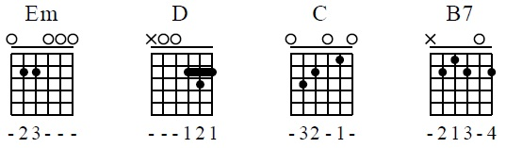

Rhythm:
T ↓ T ↓ | T ↓ T ↓↑↓

Em D C B7
Now, Old Mister Johnson had troubles of his own
He had a yellow cat who wouldn't leave his home;
He tried and he tried to give the cat away,
He gave it to a man goin' far, far away.
[Chorus]
But the cat came back the very next day,
The cat came back, they thought he was a goner
But the cat came back, he just couldn't stay away.
Now, the man around the corner swore he'd kill the cat on sight,
So he loaded up his shotgun with nails and dynamite;
He waited and he waited for the cat to come around,
Ninety seven pieces of the man is all that they found.
But you know...?
[Chorus]
So he gave it to a man going up in a balloon,
He told him for to take it to the man in the moon;
The balloon came down about ninety miles away,
Where the man is now, well I dare not say.
But you know...?
[Chorus]
So he gave it to a man going way out West,
Told him for to take it to the one he loved the best;
First the train hit the track, then it jumped the rail,
Not a soul was left behind to tell the gruesome tale.
But you know what?
[Chorus]
Now, the cat was a possessor of a family of his own,
With seven little kittens till there came a cyclone;
It tore the houses all apart and tossed the cat around,
The air was filled with kittens, but not one was ever found.
[Chorus] x2
The Cat Came Back

Rhythm:
T ↓ T ↓ | T ↓ T ↓↑↓

Em D C B7
Old Mr Johnson had problems of his own
He had a yellow cat that just wouldn't leave him alone
He tried and he tried to give the cat away
He gave it to a little man going far away
But the cat came back the very next day
Yes, the cat came back They thought he was gone,
But the cat came back He just wouldn't stay away
He gave it to a little boy with a dollar note
He told the boy to take the cat up river on a boat
The boat turned over and was never found,
And now they drag the river for the little boy who drowned
But the cat came back the very next day
Yes, the cat came back They thought he was gone,
But the cat came back He just wouldn't stay away
The man around the corner said he'd shoot the cat on sight
He loaded up his shotgun full of nails and dynamite
He waited and he waited 'till the cat came walking round
And ninety-nine pieces of the man was all they found
But the cat came back the very next day
Yes, the cat came back They thought he was gone,
But the cat came back He just wouldn't stay away
The H-bomb fell the very next day
The A-bomb fell in the very same way
Russia went! England went! And then the USA
The entire human race was left without a chance to pray
But the cat came back the very next day
Yes, the cat came back They thought he was gone,
But the cat came back He just wouldn't stay away

